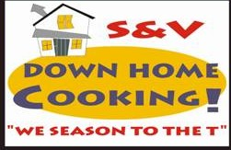

1407 North Memorial Parkway, Suite 18

Huntsville, Alabama 35801

OPEN: 8am – 7pm (Closed Wed & Sun)

Mon/Tue/Thurs/Fri/Sat

Business Phone: 256.715.0786

Fax: 256.715.0848

*Please visit our website at* [*www.svdownhomecooking-inc.com*](http://www.svdownhomecooking-inc.com/) *for a full catering menu. Or, email us at* [*svdhc@yahoo.com*](mailto:svdhc@yahoo.com) *for your catering needs!*

**S&V Down Home Cooking & Catering**

Website: [www.svdownhomecooking-inc.com](http://www.svdownhomecooking-inc.com)

Email: [svdhc@yahoo.com](mailto:svdhc@yahoo.com)

Open Mon-Sat 7am-8pm, Closed Wed & Sun

**S&V DHC**

